Def:- The keyword which modifies default functionality of programming element(class,variable,method,interface,constructor,block,…etc) is called modifier. A modifier is used for setting access and execution level permission to programming element. A modifier is used in programming element declaration before the keywords.

🡪class

🡪Datatypes

🡪Return types.

In Java , we have 13 modifiers . Among 13, 12 are keywords and one modifier is not keyword. It is just concept(Invisible). This modifier is accessibility modifier <default>.

All modifiers are divided into 3 divisions based on functionalities.

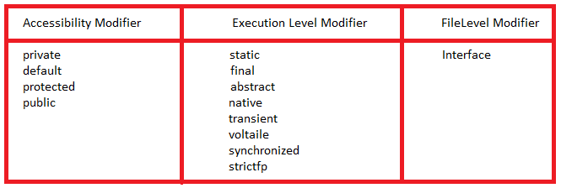

**1.Accessibility Modifier:- A**  keyword that is used for setting access scope permission is called accessibility modifier. It means by using accessibility modifier we can specify where programming element is accessed.

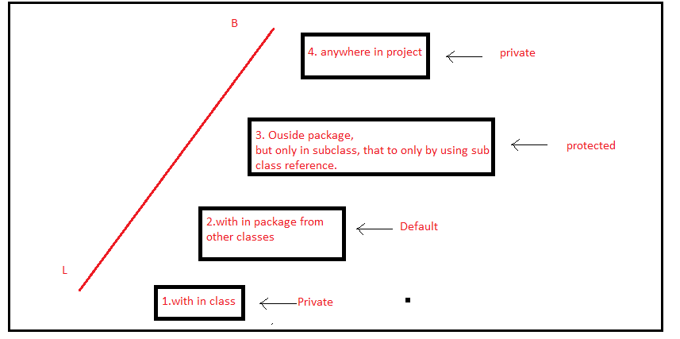

**1.1.Private:-** The class member which have private keyword in its creation statement is called private member. This member is only accessible with in that class. This member is not accessible out side this class.

Note:-1.The private keyword is not allowed to outer class.

2. The private keyword is allowed to static and non-static members of class.

3. The private keyword is not allowed to parameters and local variables.

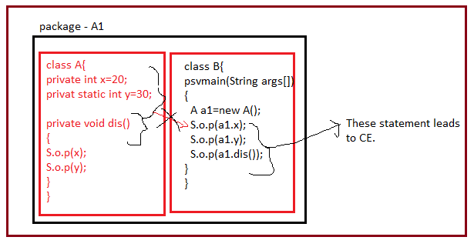

Even class A and class B are in same package, the private members of class A is not accessible in class B.

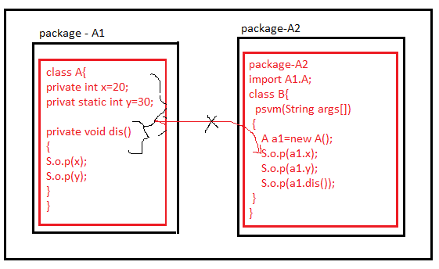

The private members of class A is not also accessible in class B of another package.

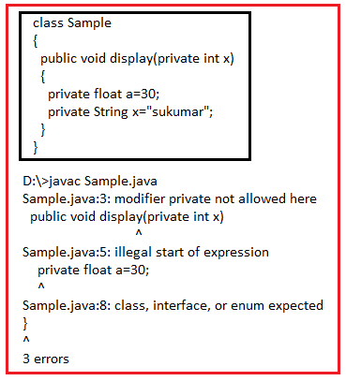

The private keyword is not allowed to local variables and parameters.

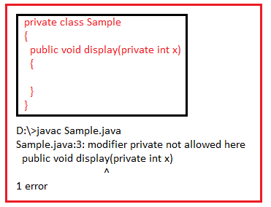

The private keyword is not allowed to class.

**1.2.Default:-** The Default programming elements is only accessible inside the package.

If we don’t use any accessibility modifier(private,protected,public) to class, package level is the default accessibility modifier of class.

If we don’t use any accessibility modifier (private,protected,public) to static members and non-static members of class, package level is default accessibility modifier of static and non-static members of class.

It is not applicable to local variables and parameters.

Example:

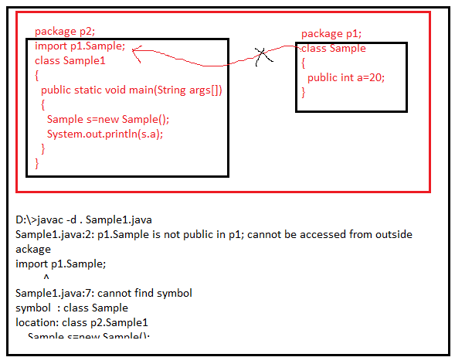

Example:2

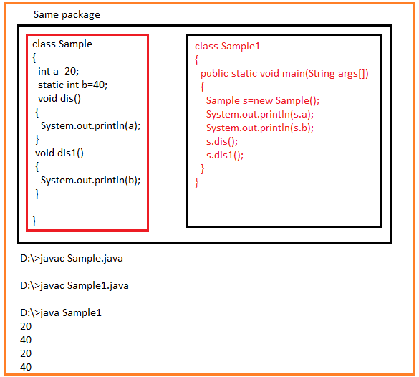

Example3:

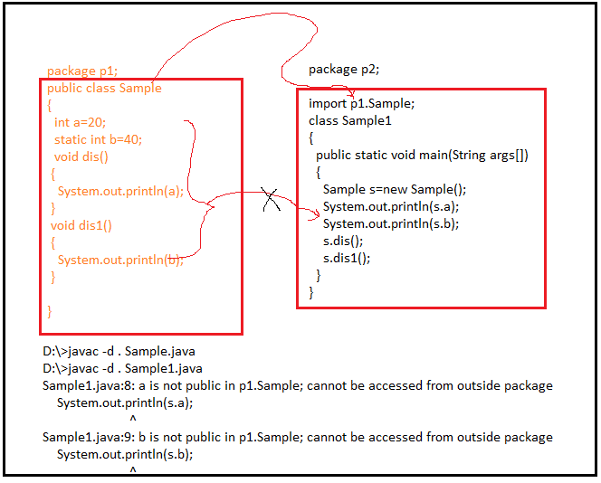

**1.3.public:-** The class and its members which have public keyword in its creation statement are called public members. Those members can be accessible from all places of java project.

Public is allowed to class, static and non-static members.

Public is not allowed to local variables and parameters.

Example:

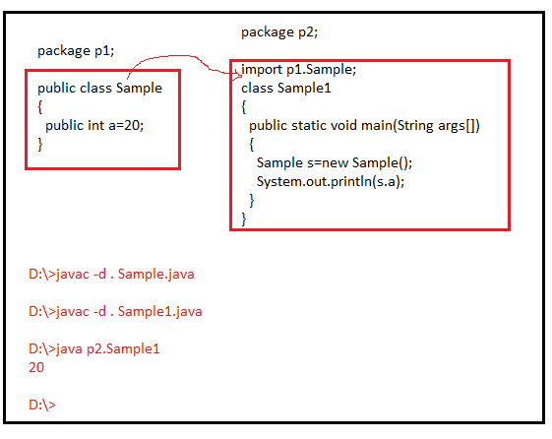

**1.4.protected:-** The class members which have protected keyword in its creation statement are called protected members. Those members can be accessible with in package from all classes, but from outside package only in sub class that too only by using sub class object(This rule is only for non-static protected members. Static protected members can be accessible by using same class name or by using sub class name).

The protected is allowed to class,static and non-static members.

The protected is not allowed to local variables and parameters.

Example:1

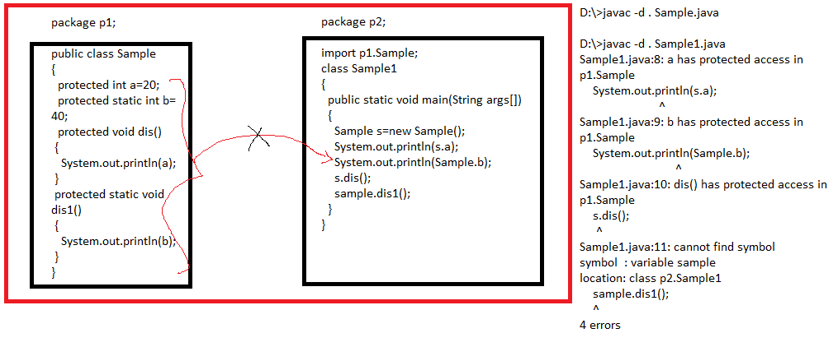

Example:2

